Music Store Analysis

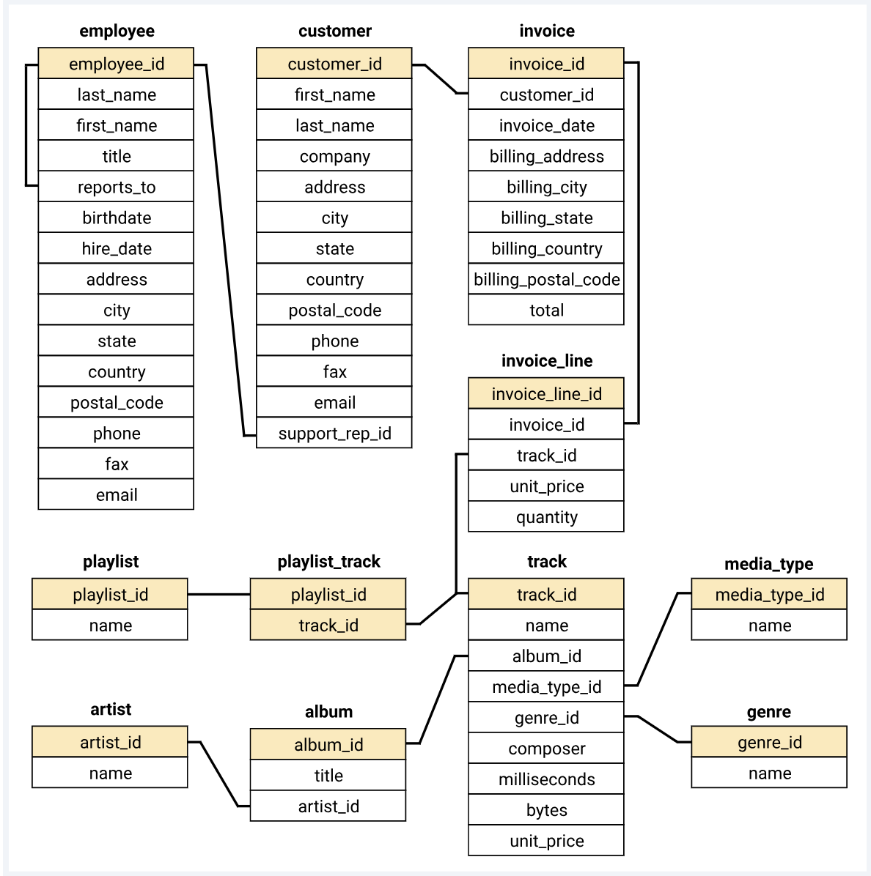
Database Schema:
Problem Statements:

- Who is the senior most employee based on job title?
SELECT title, last_name, first_name
FROM employee
ORDER BY levels DESC
LIMIT 1
- Which countries have the most Invoices?
SELECT COUNT(*) AS c, billing_country
FROM invoice
GROUP BY billing_country
ORDER BY c DESC
- What are top 3 values of total invoice?
SELECT total
FROM invoice
ORDER BY total DESC
- Which city has the best customers? We would like to throw a promotional Music Festival in the city we made the most money.

SELECT billing_city,SUM(total) AS InvoiceTotal
FROM invoice
GROUP BY billing_city
ORDER BY InvoiceTotal DESC
LIMIT 1;
- Who is the best customer? The customer who has spent the most money will be declared the best customer.
OR
Write a query that returns the person who has spent the most money.

SELECT customer.customer_id, first_name, last_name, SUM(total) AS total_spending
FROM customer
JOIN invoice ON customer.customer_id = invoice.customer_id
GROUP BY customer.customer_id
ORDER BY total_spending DESC
LIMIT 1;

- Write query to return the email, first name, last name, & Genre of all Rock Music listeners.
Return your list ordered alphabetically by email starting with A.
SELECT DISTINCT email,first_name, last_name
FROM customer
JOIN invoice ON customer.customer_id = invoice.customer_id
JOIN invoice_line ON invoice.invoice_id = invoice_line.invoice_id
WHERE track_id IN(
SELECT track_id FROM track
JOIN genre ON track.genre_id = genre.genre_id
WHERE genre.name LIKE 'Rock'
)
ORDER BY email;

- Let's invite the artists who have written the most rock music in our dataset.
Write a query that returns the Artist name and total track count of the top 10 rock bands.

SELECT artist.artist_id, artist.name,COUNT(artist.artist_id) AS number_of_songs
FROM track
JOIN album ON album.album_id = track.album_id
JOIN artist ON artist.artist_id = album.artist_id
JOIN genre ON genre.genre_id = track.genre_id
WHERE genre.name LIKE 'Rock'
GROUP BY artist.artist_id
ORDER BY number_of_songs DESC
LIMIT 10;

- We want to find out the most popular music Genre for each country. We determine the most popular genre as the genre with the highest amount of purchases. Write a query that returns each country along with the top Genre. For countries where the maximum number of purchases is shared return all Genres
WITH popular_genre AS
(
SELECT COUNT(invoice_line.quantity) AS purchases, customer.country, genre.name as Genre_name, genre.genre_id,
ROW_NUMBER() OVER(PARTITION BY customer.country ORDER BY COUNT(invoice_line.quantity) DESC) AS RowNo
FROM invoice_line
JOIN invoice ON invoice.invoice_id = invoice_line.invoice_id
JOIN customer ON customer.customer_id = invoice.customer_id
JOIN track ON track.track_id = invoice_line.track_id
JOIN genre ON genre.genre_id = track.genre_id
GROUP BY 2,3,4
ORDER BY 2 ASC, 1 DESC
)
SELECT * FROM popular_genre WHERE RowNo <= 1

- Determine which customer has spent the most on music for each country.
OR
Write a query that returns the country along with the top customer and how much they spent.

WITH Customter_with_country AS (
SELECT customer.customer_id,first_name,last_name,billing_country,SUM(total) AS total_spending,
ROW_NUMBER() OVER(PARTITION BY billing_country ORDER BY SUM(total) DESC) AS RowNo
FROM invoice
JOIN customer ON customer.customer_id = invoice.customer_id
GROUP BY 1,2,3,4
ORDER BY 4 ASC,5 DESC)
SELECT * FROM Customter_with_country WHERE RowNo <= 1 order by total_spending desc

